
Land Information Ontario (LIO) Warehouse
Data Class Name: Wooded Area
Documentation
Produced by: Information Access and Information Management Policy Unit
Ministry of Natural Resources and Forestry
Date: July 27, 2015

Purpose

This document provides additional information to support the use of geospatial data. The Physical Model Diagram provides a visual representation of the relationships in the data class. The Data Change History lists all the modelling and access changes that have occurred during the lifecycle of the data class. A data description identifying table and field names is available upon request.

Need Assistance?
Please contact LIO Support at lio@ontario.ca or 705-755-1878 if you require help.

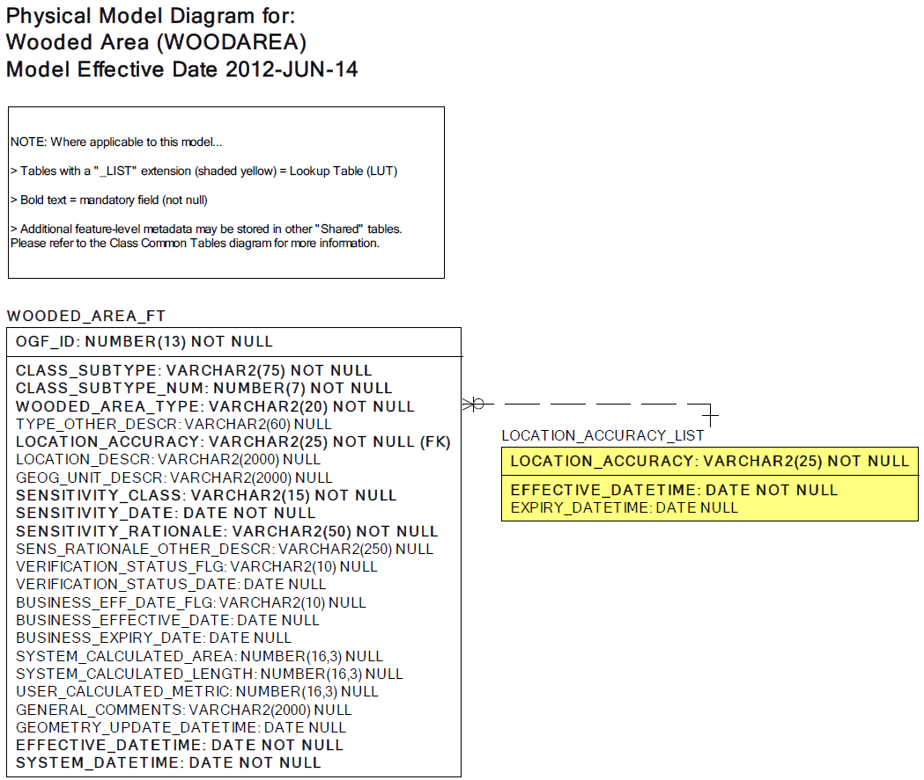

Data Class Change History

Data Class Name: Wooded Area
Data Class Short Name: WOODAREA
Date  YYYY-MM-DD | Details of Change
2007 | Table Added: WOODED_AREA with two new columns:  - Wooded Area Type  - Type Other Description
2002 | Converted to structured data class with the following Common Tables added:  - GEOG_UNIT  - EXTERNAL_REFERENCE  - JUSTIFICATION
1996 | New unstructured data class (OBM Origin) for NRVIS 1.0
Data Description
Please refer to the metadata record for the data description.

